Kinder Morgan Report:
1. Go to this link: https://hazmatonline.phmsa.dot.gov/IncidentReportsSearch/search.aspx
Enter KINDER MORGAN in Line 10 - Carrier/Reporter
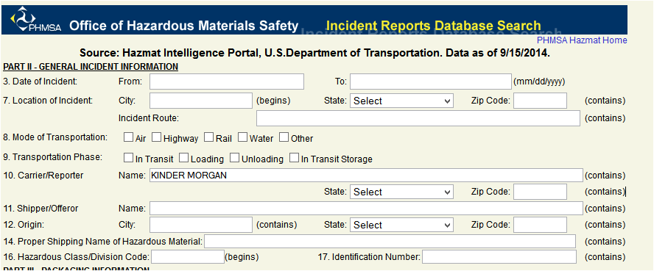
2. Scroll down to bottom of form, click search
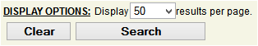
3. It will take a few seconds and won’t show up on a separate page, so scroll down the page again to see the reports:
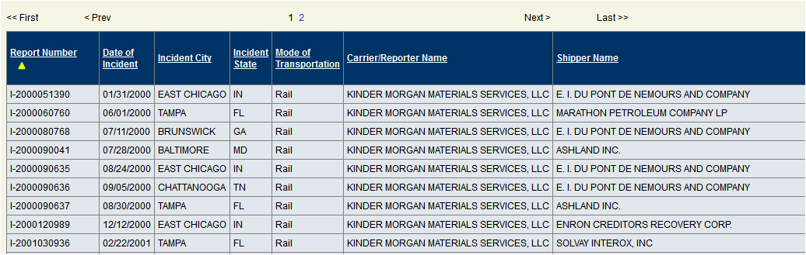
4. You can EXPORT to a spreadsheet